Proposed IIH Governing Council Members & Bios

The Governing Council of the Ilorin Innovation Hub is a strictly professional body composed of individuals that will contribute their network and wealth of experience in the tech industry towards the success of the Hub. It is advised that the council not be politicized and be focused solely towards performance-driven results and overseeing the affairs of the Hub. With this in mind. we are still working with (but not limited to) mostly members from Kwara in the technology space.

The Council members will work pro-bono as part of their contribution to Kwara State and the tech community. They will also be given first investor rights to invest in our startups.

The Council will be unpaid and run as a board of trustees with no shareholding or profit sharing and given legal power to oversee the affairs of the Innovation Hub. The main benefits of the Governing Council are:

- Credibility - A council with solid and trustworthy members gives credibility and comfort to investors
- Attracting funding - A board of trustees structure ensures that management and oversight of the Hub is not for profit and impact-based. This will encourage grants from donor and impact investment agencies.
- Quality Programs. The council will ensure a high standard of quality of programs and delivery due to the network council members will open the Hub to.
- International recognition. Members who head global multi-million dollar companies can only bring more international recognition to the Hub

SN | Name | Current Position/Reason | Origin
1 | Kazeem Oladepo   | - Vice President at IHS Towers  - Former Counsel/Company Secretary at Main One  - MSc Information Technology & Telecommunications Law  - Experience mentoring technology entrepreneurs & passion for innovation  - Helped with pro-bono advisory since planning began  - IHS already donated fit-out equipment as CSR to the Hub with hope of more assistance | Kwara
2 | Iyin Aboyeji  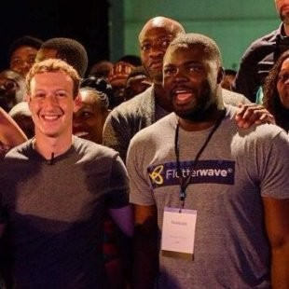 | - Founder & General Partner Future Africa  - Former Co-Founder & Managing Director Flutterwave  - Former Co-Founder & Director Andela | Kwara
3 | Bosun Tijani (PhD)   | - Co-Founder & CEO CCHub (Nigeria’s first and most successful tech hub)  - Research fellow  - STEM Expert  - Ecosystem building expert | Non-Kwara
4 | Musty Mustapha  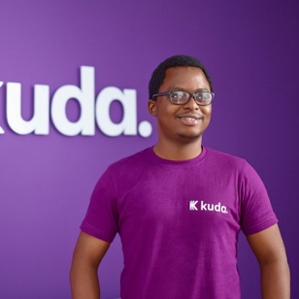 | - CTO Kuda Bank (Nigeria’s top digital bank that has raised over $50m)  - UNILORIN Alumni | Kwara
5 | Adia Sowho   | - CMO MTN Nigeria  - Will strengthen relationship with MTN  - Tech entrepreneur, investor & mentor  - Member of same business network as MD | Non-Kwara
6 | Wadami Amolegbe   | - Passion for Education & Learning  - Entrepreneur with passion for tech | Kwara
7 | Temi Kolawole  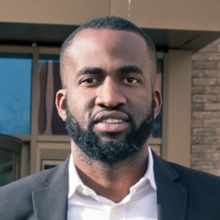 | - MD Ilorin Innovation Hub  - Serial entrepreneur  - Startup mentor & ecosystem builder | Kwara
8 | Bola Lawal   | - Serial entrepreneur in Edtech, events & networking  - Founder Permia Business Network  - Passionate about startups and technology | Non-Kwara
9 | Osita Nwoye   | - Board member Ventures Platform  - Investor in Paystack, Printivo, PiggyVest, Tizeti and other top startups in Nigeria.  - #1 networker in the Lagos technology scene. He is connected to all major startups and investors in Lagos & Silicon Valley. | Non-Kwara
10 | TBD | Any other members recommended by HE

